**Input:**

f(x): ex *

h = 0.01

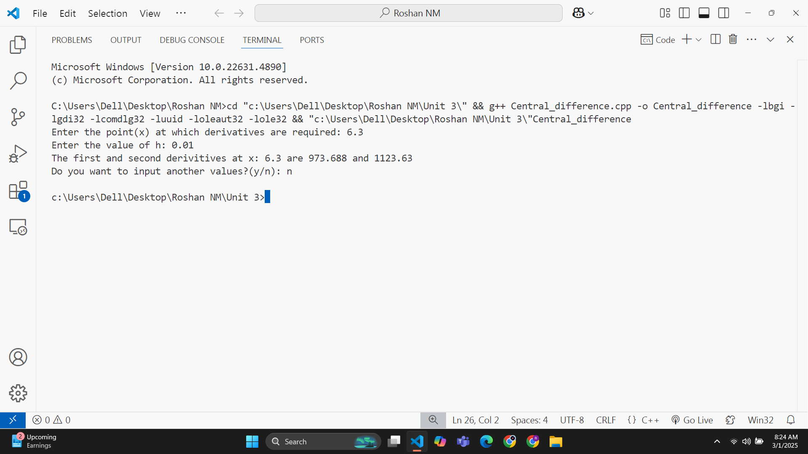**Output:**

**Input:**

f(x) = x2 * ex +sin(x)

h = 0.01

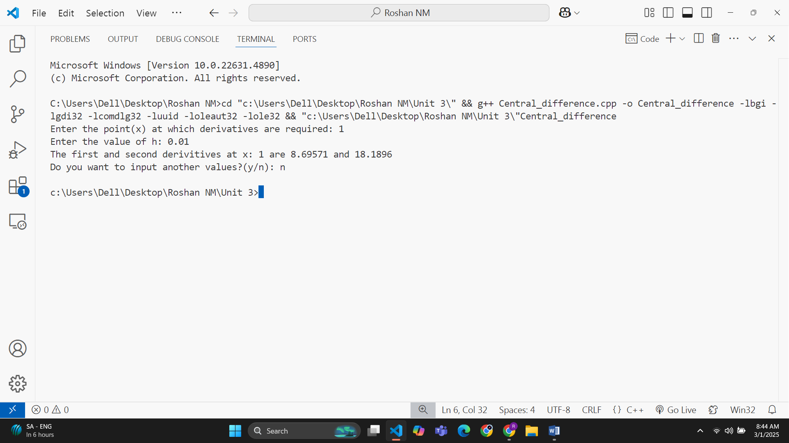**Output:**

|  |  |  |  |  |
| --- | --- | --- | --- | --- |
| x | 2 | 3 | 5 | 6 |
| f(x) | 3 | **7** | 21 | 31 |

**Input:**

Derivative at(**x**) : 4.1

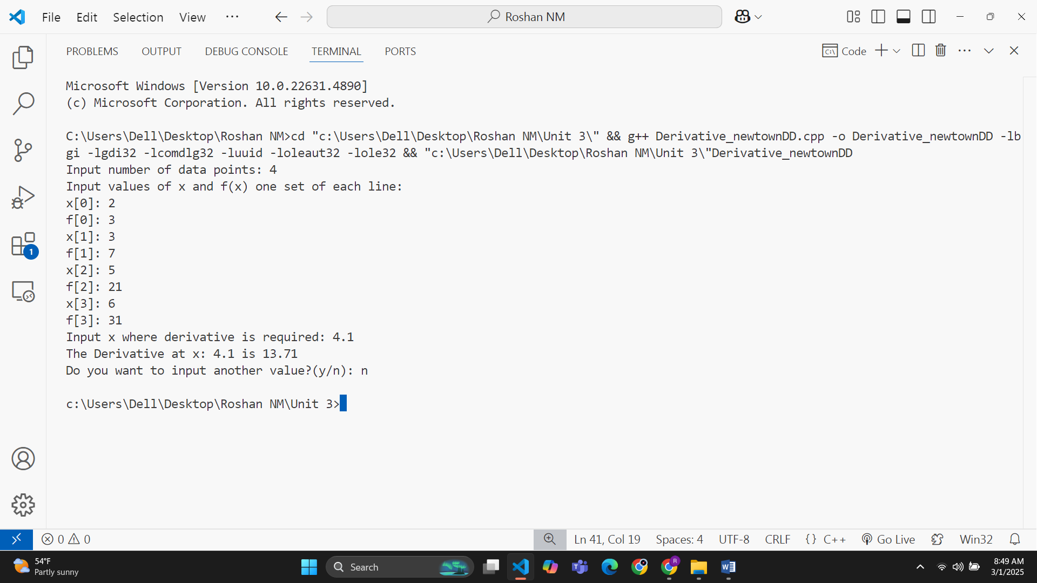**Output:**

|  |  |  |  |  |  |
| --- | --- | --- | --- | --- | --- |
| x | 5 | 7 | 11 | 13 | 17 |
| f(x) | 150 | 392 | 1452 | 2366 | 5202 |

**Input:**

Derivative at(**x**) : 9

**Output:**

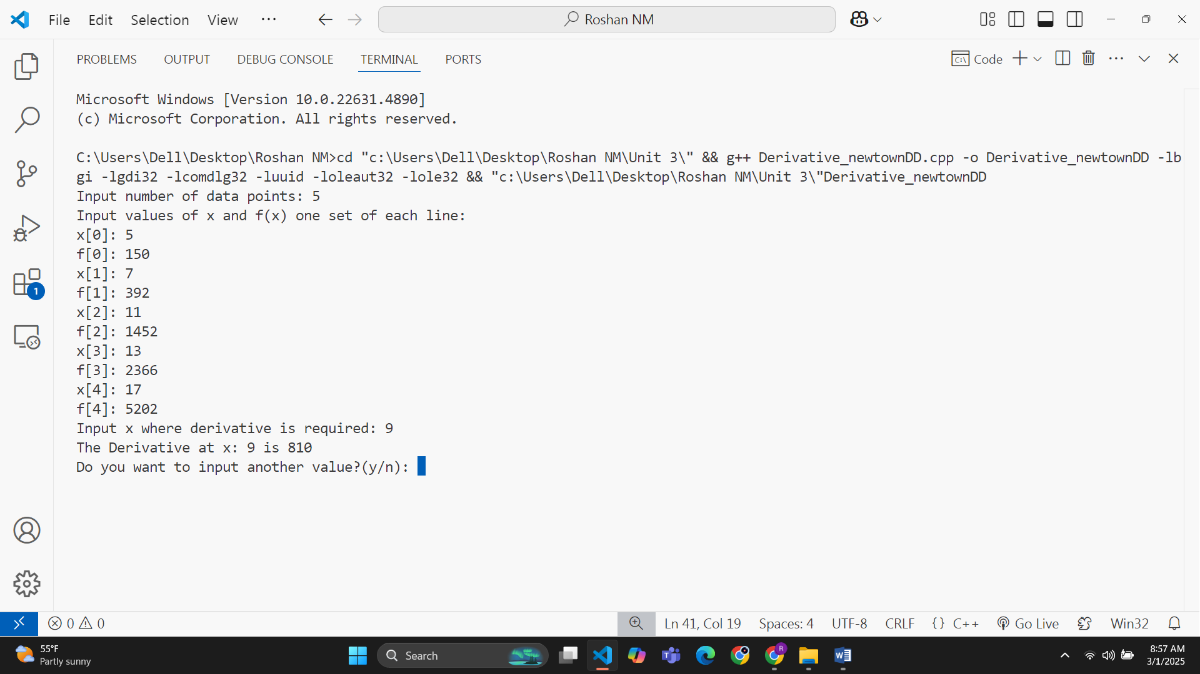

|  |  |  |  |  |  |
| --- | --- | --- | --- | --- | --- |
| x | 0 | 0.5 | 1 | 1.5 | 2 |
| f(x) | 1 | 0.6064 | 0.3676 | 0.2231 | 0.1353 |

**Input**-x dx

**Output:**

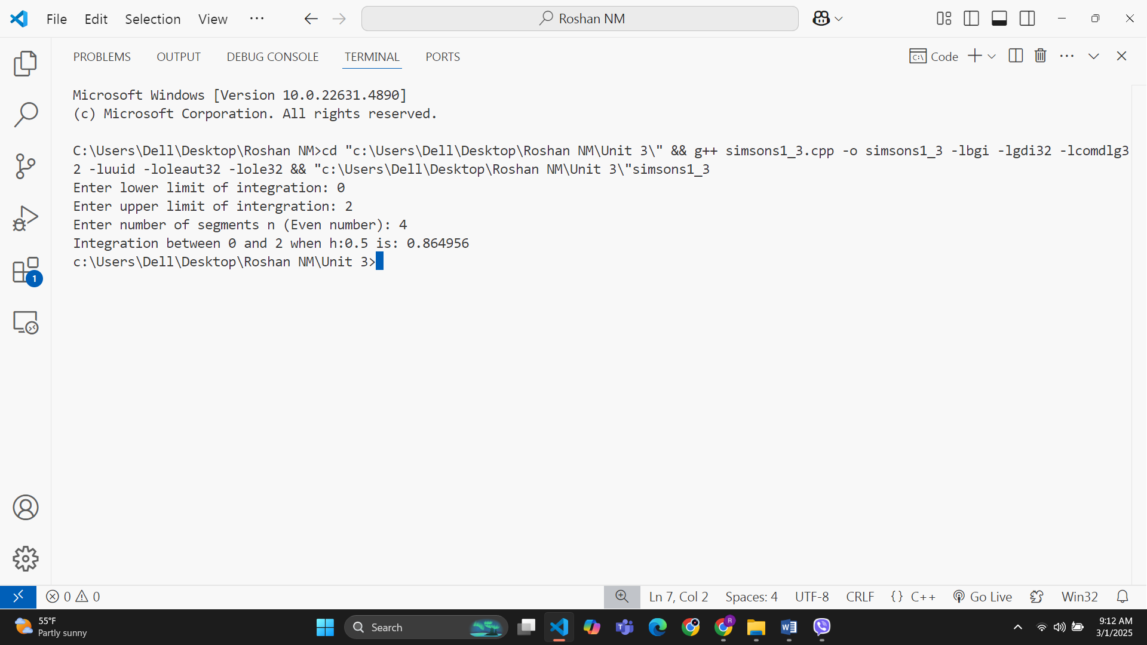

**Input:**

Given:

|  |  |  |  |  |  |
| --- | --- | --- | --- | --- | --- |
| f(x) | 0 | 0.25 | 0.5 | 0.75 | 1 |
| x | 1 | 0.94117 | 0.8 | 0.64 | 0.5 |

**Output:**

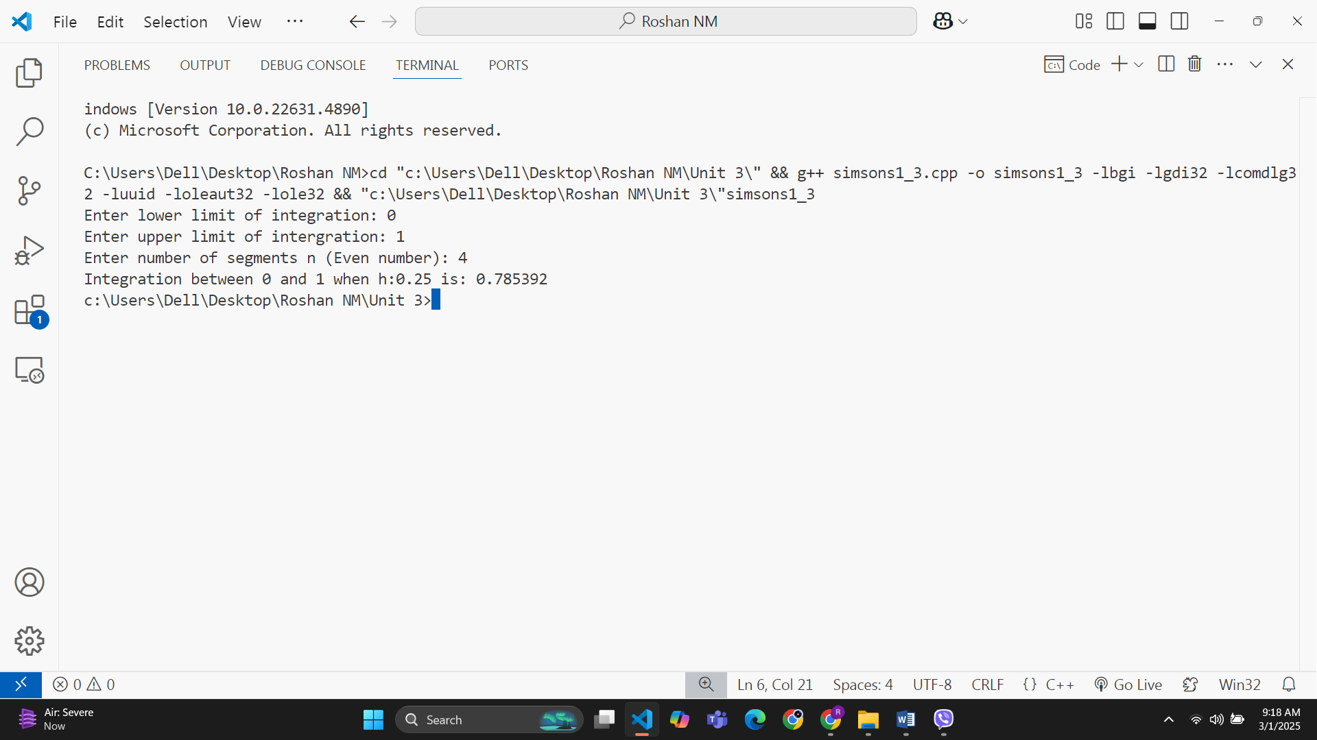

**Input:**

|  |  |  |  |  |  |  |  |
| --- | --- | --- | --- | --- | --- | --- | --- |
| f(x) | 0 | 0.166667 | 0.33333 | 0.5 | 0.66667 | 0.83333 | 1 |
| x | 2 | 1.99 | 1.92 | 1.78 | 1.54 | 1.26 | 1 |

Given:

**Output:**

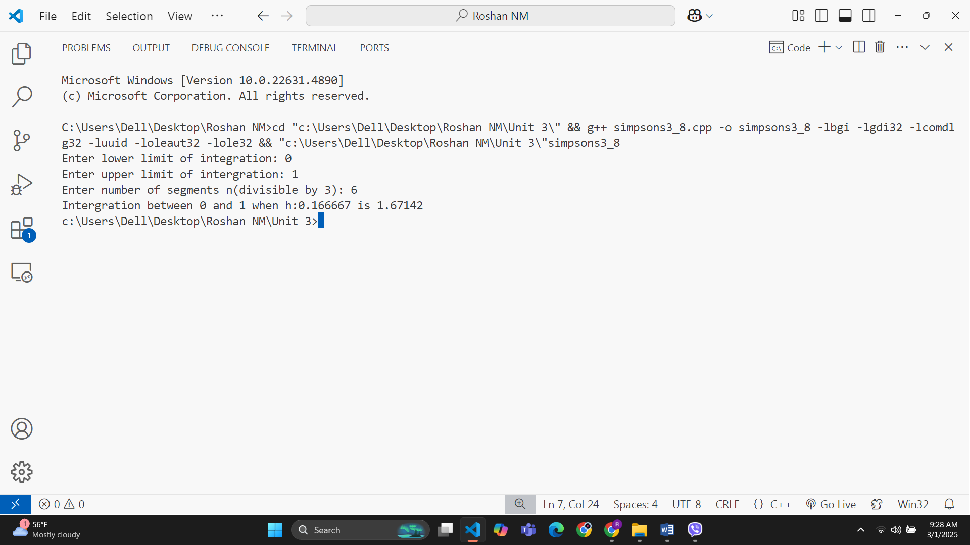

**Input:**

|  |  |  |  |  |
| --- | --- | --- | --- | --- |
| f(x) | 1 | 2 | 3 | 4 |
| x | 1 | 8 | 27 | 64 |

Given:

**Output:**

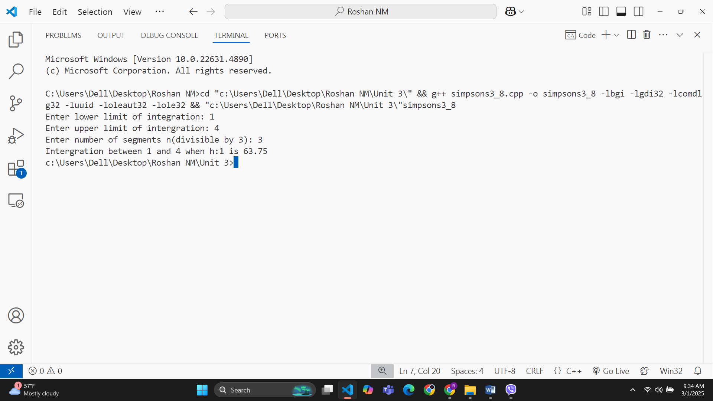

**Input:**

|  |  |  |  |  |  |  |  |
| --- | --- | --- | --- | --- | --- | --- | --- |
| f(x) | 0 | 1 | 2 | 3 | 4 | 5 | 6 |
| x | 1 | 0.5 | 0.2 | 0.1 | 0.0588 | 0.0385 | 0.027 |

**Given:**

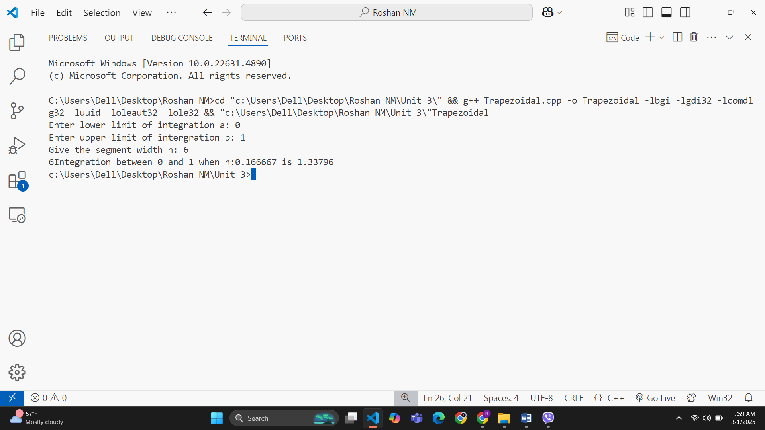**Output:**

**Input:**

|  |  |  |  |  |  |
| --- | --- | --- | --- | --- | --- |
| f(x) | 0 | 0.5 | 1 | 1.5 | 2 |
| x | 1 | 1.25 | 2 | 3.25 | 5 |

**I =**

**Output:**

